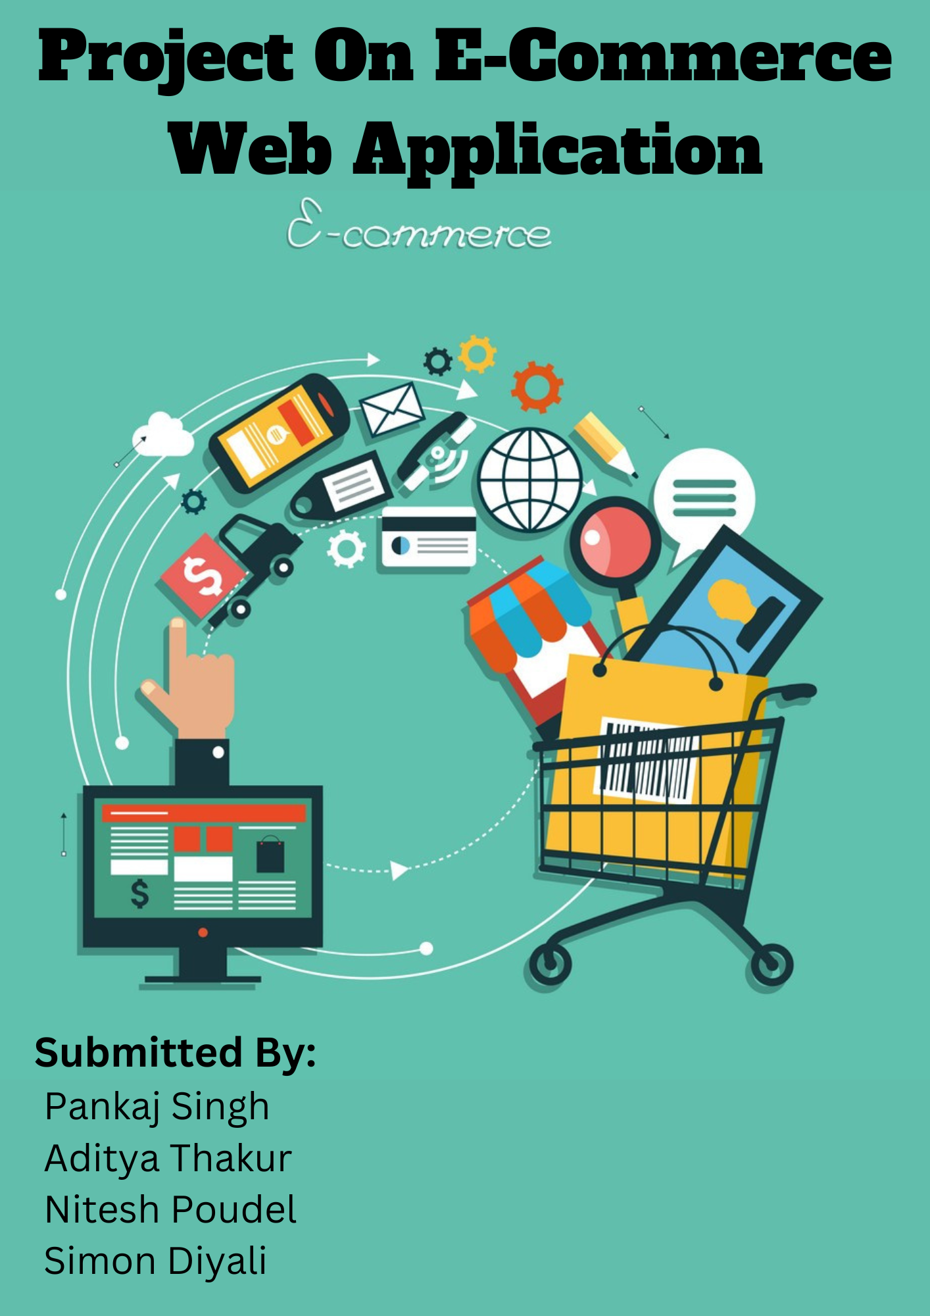

Contents

Introduction 2

Keywords: 3

Aim 3

Objectives: 3

Problem Statement 3

Solution 4

User Features 4

Technologies Used 5

Tools: 6

Methodology 6

Working Mechanism of your application 7

Appendix: 7

My Role in This Project 8

Front End Development 8

Issues During the Project Development 26

Project Limitation 26

Future Works 27

Conclusion: 27

Similar Products: 27

References 27

**AttireApp**

# Introduction

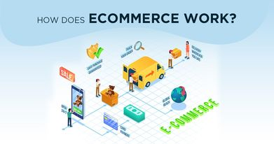As an E-Commerce web application our project intends to provide customer and seller an interface where they can easily buy or sell products at an online platform. As a customer I can easily browse the products which I want to buy as well as see and compare the prices which are arranged properly in this web app. And as a seller, I have a separate database where my inventory and my sales along with orders and customer details are stored. I can easily update my inventory along with their prices and deliver our products to fulfill the needs of needy customers.

This web application provides business to customers type of interface which benefits both the customer and seller.

# Keywords:

Ecommerce, Agile Development, User Features, Tools and Tech, Clothing

# Aim

The main aim of our web application is to provide an online platform which facilitates both the seller and the customer to buy and sell the products of their choice. With the help of online payment, it ensures easy, reliable and secure exchange of products. It also benefits workers by giving them job opportunities like delivery boy, store manager, etc.

# Objectives:

The objectives of our project are stated down below:

* Establish a deeper relationship between seller and customers.
* Provide unique Customer Experiences with fluent UI/UX.
* To be the mediator between seller and customer by giving them common platform.
* To give easy, reliable and secure method of payment.
* Give user a provision to leave reviews and comments about the product.

# Problem Statement

As evolving from traditional era to a digital era, the methods of doing business has changed drastically. More and more people rely upon online platform to buy and sell products. A large number of people prefer digital money over physical cash which are more reliable and secure. But in context of Nepal, neither the customer nor the seller has a good experience with the functioning of present online ecommerce application. The risk of frauds and poor user experience is still prevalent in this market.

# Solution

To tackle the various problem as mentioned above, our application acts as a reliable solution by providing a common platform where seller can list their products and customer can browse through the products and buy the products of their choice. It provides a reliable and secure payment option which reduces the risk of frauds. It only allows genuine seller and products which ensures the quality of the products.

# User Features

1. Login.

As a user, I need to be able to login to the system so that I can browse through the system.

1. Registration.
2. As a new user, I need to be able to register to create an account to access login feature. So, then I can be a valid user of the company.
3. Search Bar.

In this portion, all the user should be able to perform the queries like searching system has been enabled for ease of finding products.

1. Banner

Here, we write the content about the store where customers attraction can be simplified with images and link tab.

1. Categories

Here, we display the fashion wears with different products images and new fashion wear products where users see easily.

1. Featured Product.

As a client we are able to see the new products with all the content mentioned with size, prices and with product title.

1. Services

In this area, we provide the list of different service facilities like save time, save money, online order, free shipping, support for customer criteria.

1. Newsletter

Here we deliver the appropriate content where clients can sign up with their email address.

1. Contact.

This section provides all the brief about the company details where company fields are filled with locations and time table.

1. About

These criteria tells us about the store information like privacy policy, terms and conditions, buyer, seller info delivery information etc.

1. My Account

In this content we provide the heading and paragraphs where sign in, view cart, Wishlist, track my order, help and cashpoints are mentioned.

1. Follow us

This provide the social site about store where client can contact with us at any available modes.

1. Download App

This provide the store details where clients can get our website app from app store and play store.

1. Online Gateway Partners.

This will tells us about the payments mode available while purchasing the products via online system.

1. Copyright

We display the content like which company has written the codes for the website.

1. Browsing and Listing of products

As a user, I need to be able to see all product, so that I can find desired product efficiently. As a user, I need to be able to list my product with their prices.

1. Buying the products

As a user, I need to be able to select product, so that I can buy desired number of products.

1. Admin Features

As a user, I need to be able to add or remove products, so that I can update the listings.

1. Payment

As a user, I must be able to select payment details, so that I can do online transaction on the system.

1. Database Features

As a user, I want to have a database that includes my listing sales and customer details so that I can see my transaction details.

# Technologies Used

* Spring Boot
* Java
* Html
* Bootstrap
* Postgre Sql
* Javascript
* Jquery
* Css

# Tools:

* Visual Studio
* GitHub
* Trello
* MS Word
* Excel
* Google

# Methodology

The capacity to innovate and adapt to change is agile. It is a strategy for navigating a complex and chaotic environment and ultimately prospering in it. It expedites the delivery of early business value and ensures that value is continually optimized throughout the development process through a process of continuous planning and feedback. Teams are able to consistently align the supplied software with intended business demands as a result of this iterative planning and feedback loop, quickly adjusting to shifting requirements throughout the process.

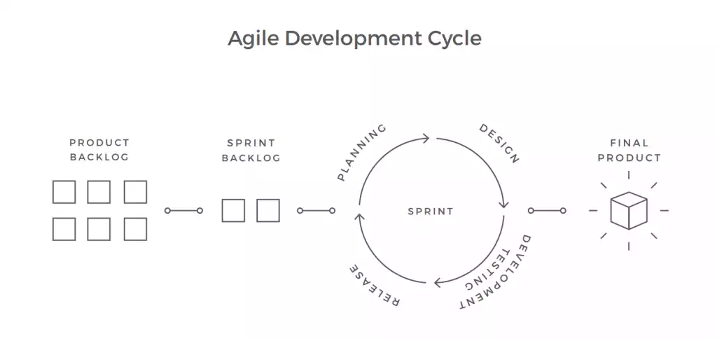

# Working Mechanism of your application

Our application mainly depends upon an interface which is developed by using flutter and dart that guides user to the listing of products listed by the seller from which they can add it to their carts. User first need to register a new account or login to the previously registered account to browse through the system. User need to provide valid login credentials and proper user details in order to access the system. User can choose their payment methods and pay for the products. The user can leave a review and comment based on their experience on the platform. User can easily return the products if he/she has any inconvenience.

# Appendix:

**SWOT Analysis**

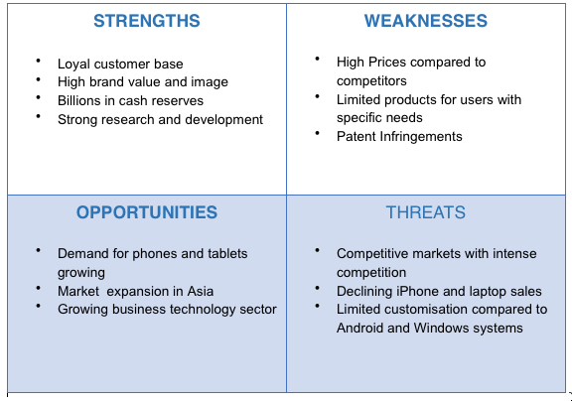

# My Role in This Project

I was the front-end developer of this project; First I make decision about the website layouts contents and keywords latterly I start to work on those sorts of things. I start to work on the login, registration, search bar, banner, featured product, display of the product, product details, services, newsletter, contact, about, my account, follows us, Download App, Online Payment Gateways Means & Modes and copyright where all text field and contents was delivered. As a front-end developer, I have to work with Html, CSS was coded as per requirement so of them were good and some could be ugly. All the setup was done inside the Spring Boot App inside the template folder where HTML/CSS/JavaScript folder are mentioned and accordingly all files are located there as we see in work.

At first, I started to write the code for all the html and display of the output has been mentioned clearly.

# Front End Development

# Screenshots:

Login Display and its Code.

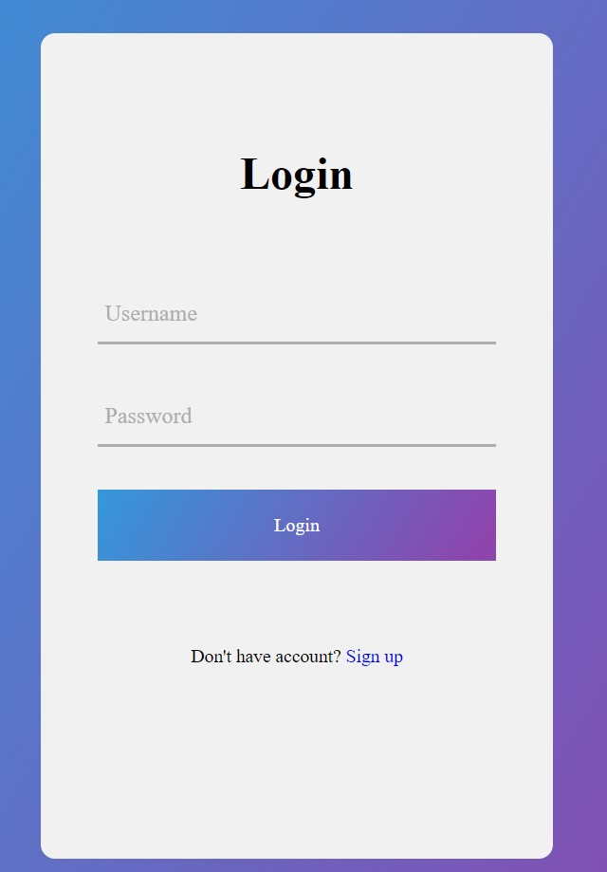 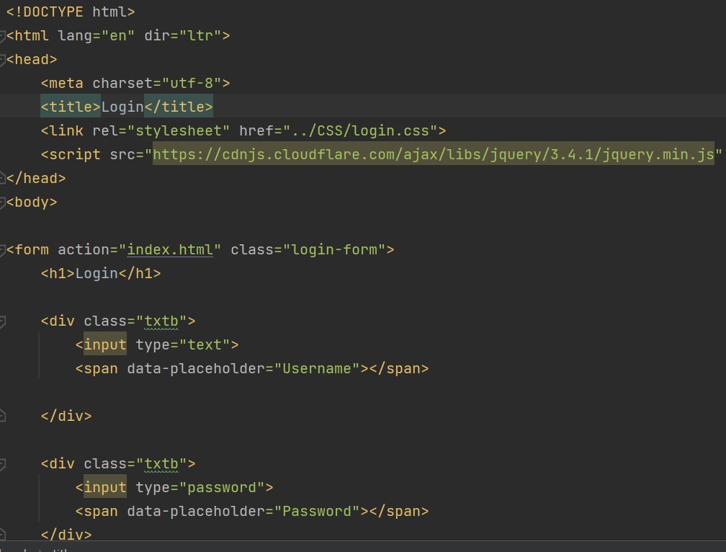

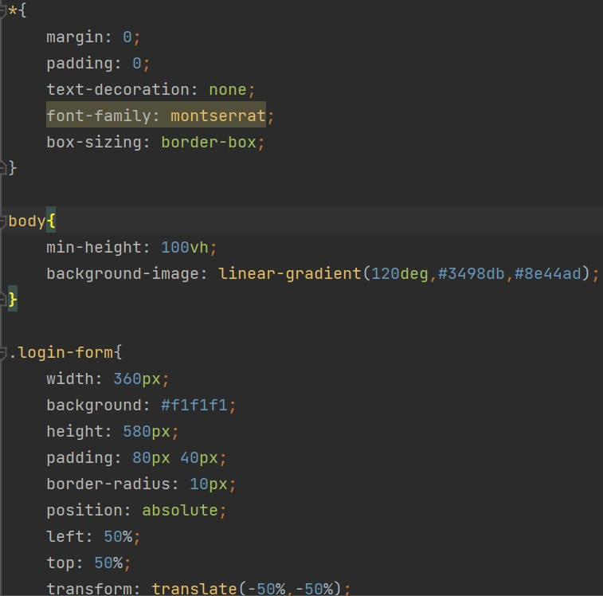

Registration and its Code:

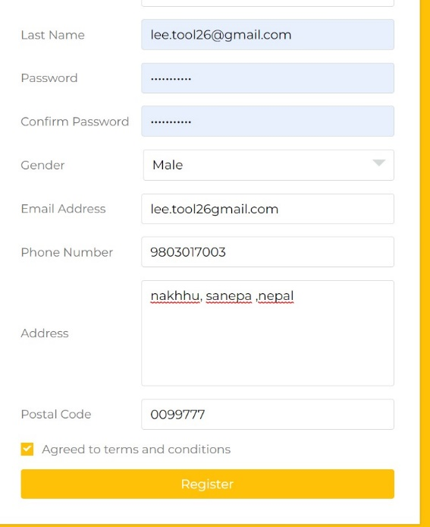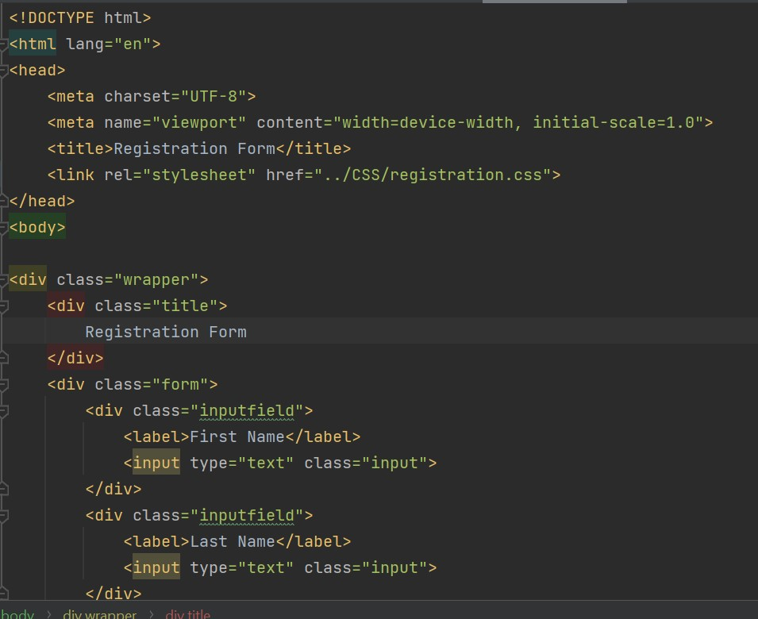

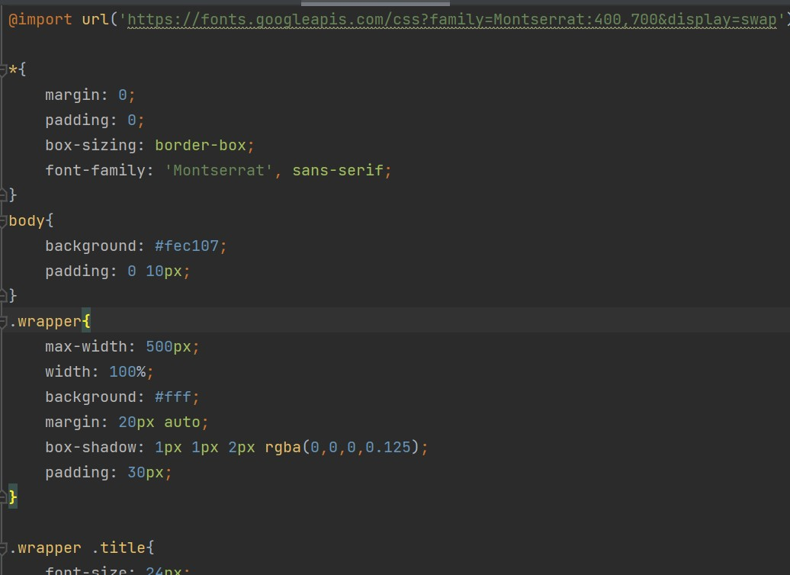

Search Tab and Working

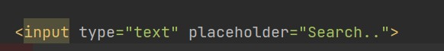

Different Pages of Website

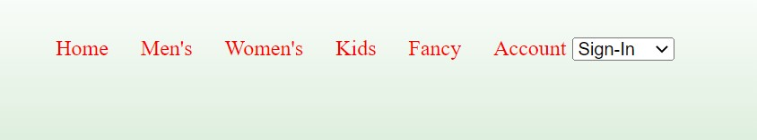

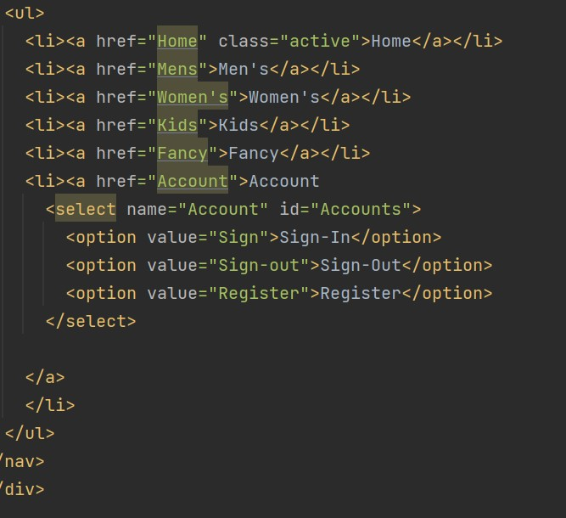

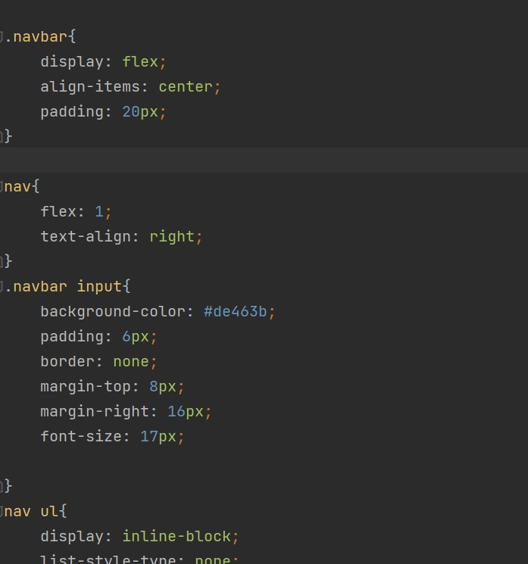

Exploration of Shop



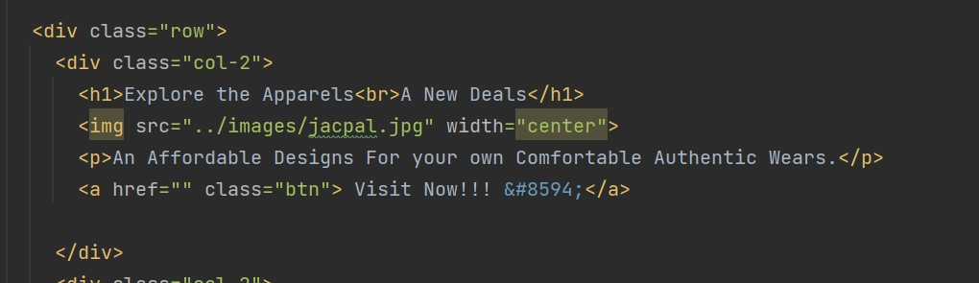

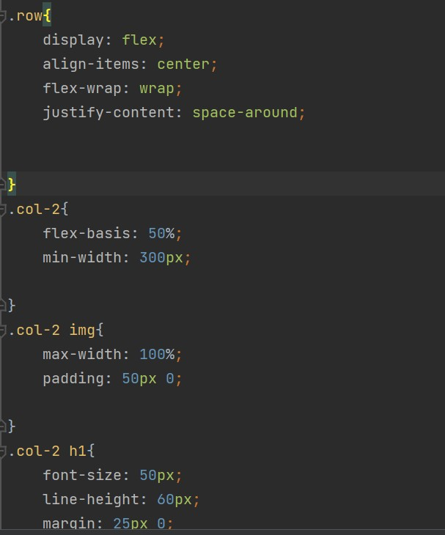

Products Display:

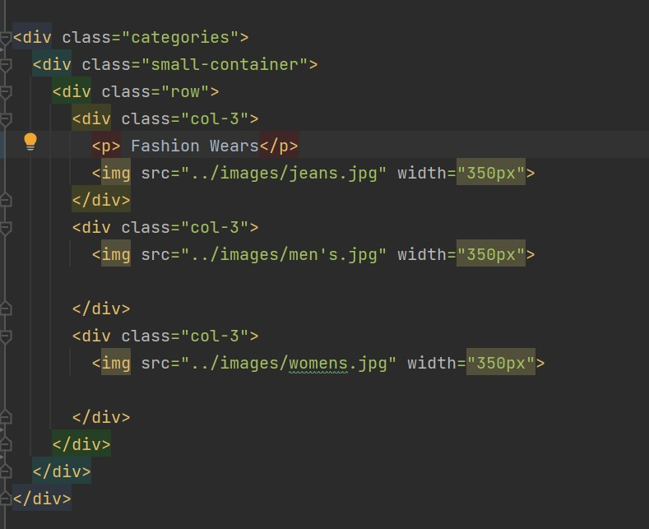

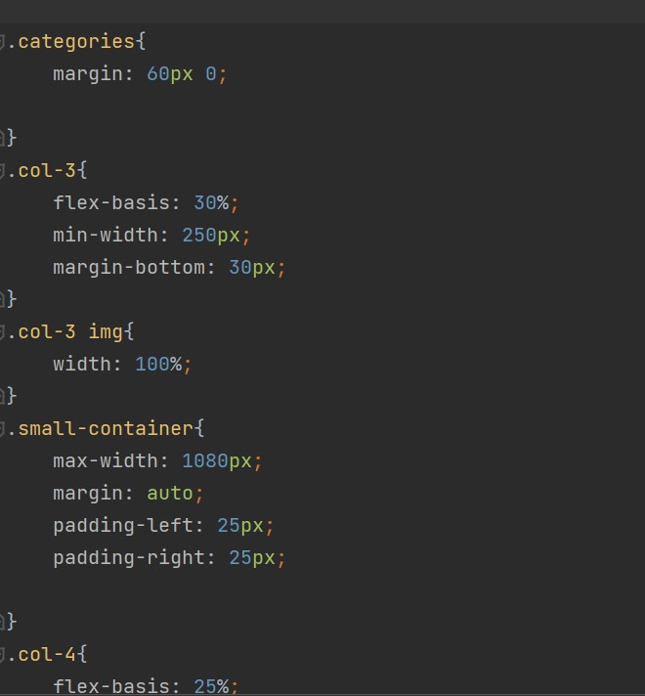

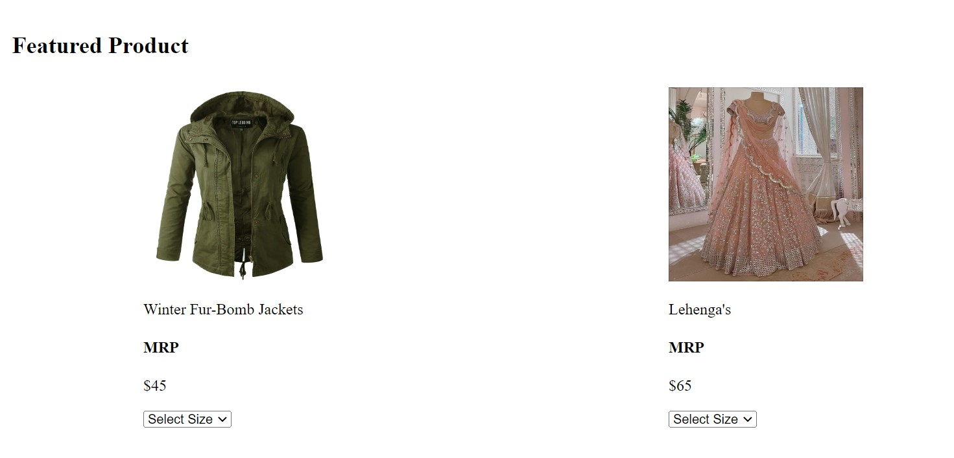

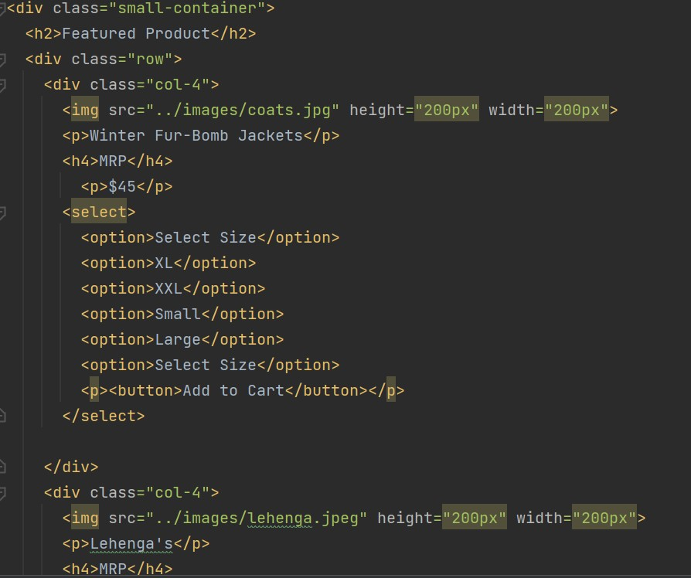

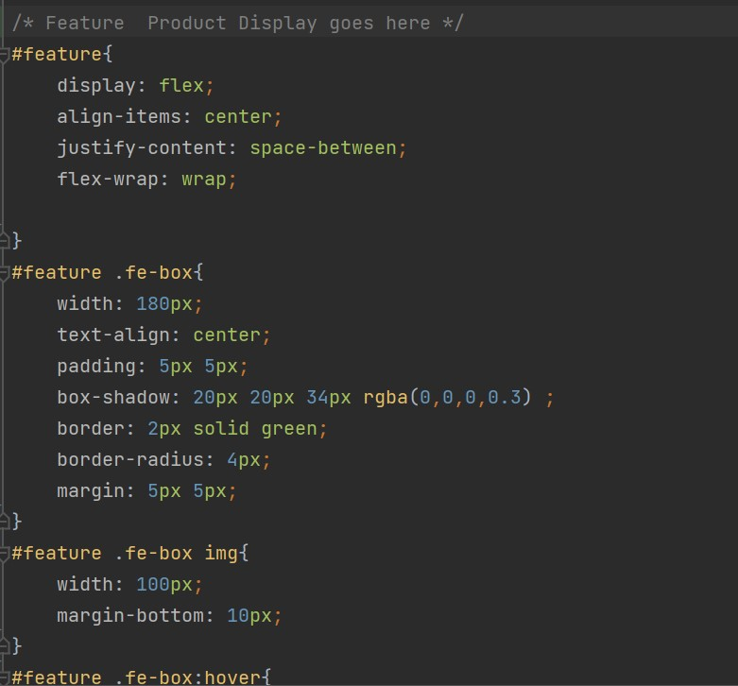

Services:

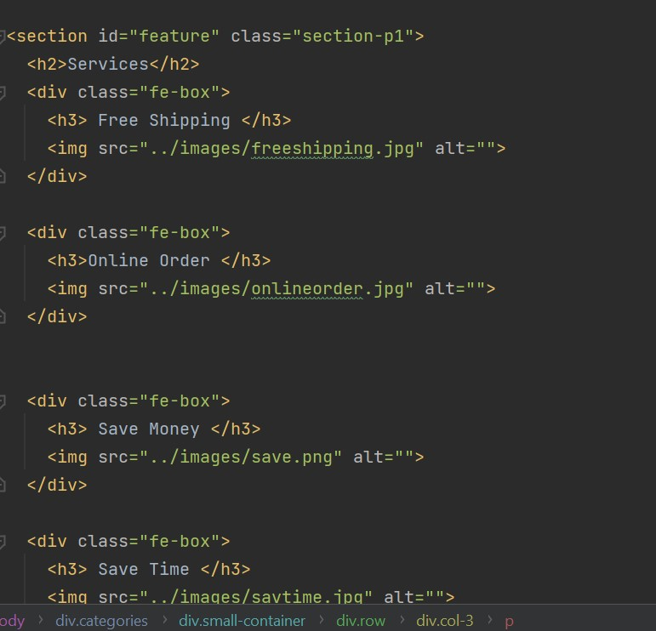

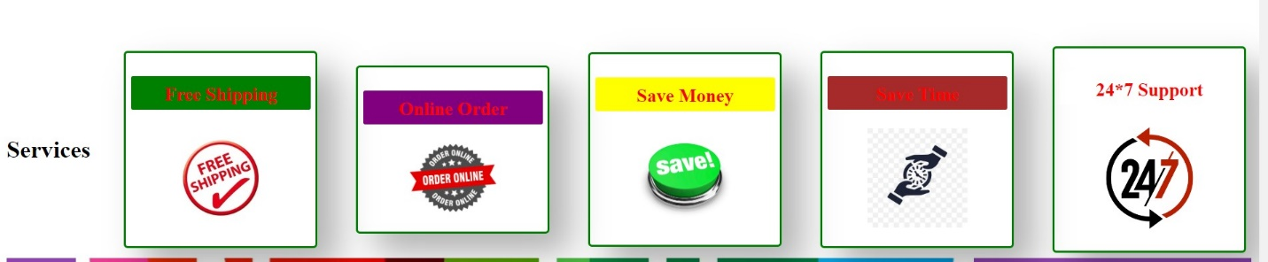

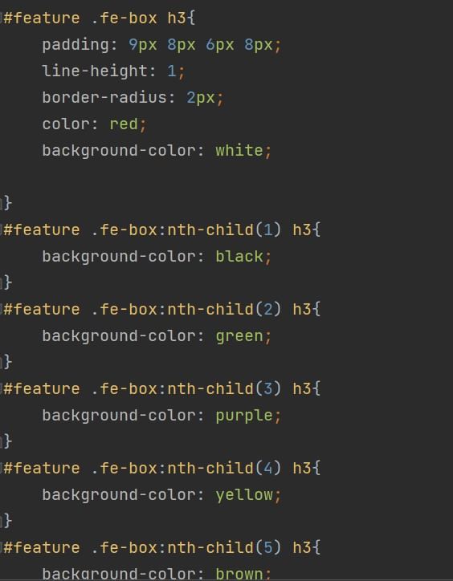

Newsletter:

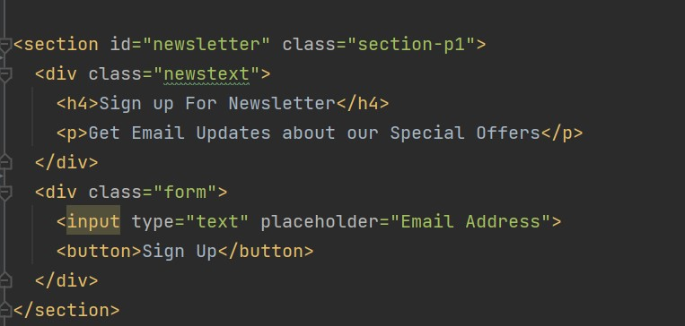



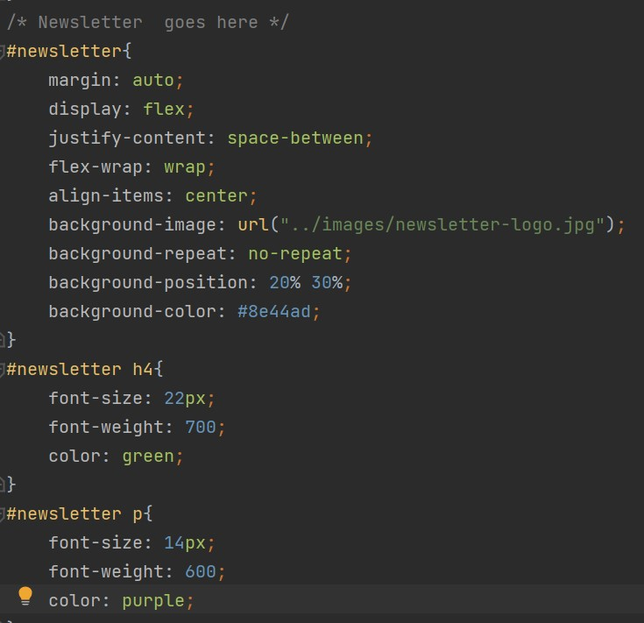

Contact:

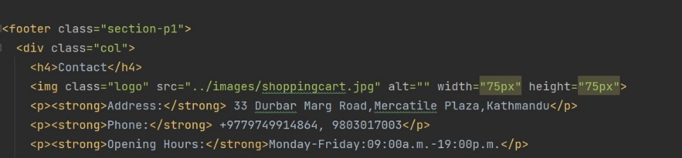

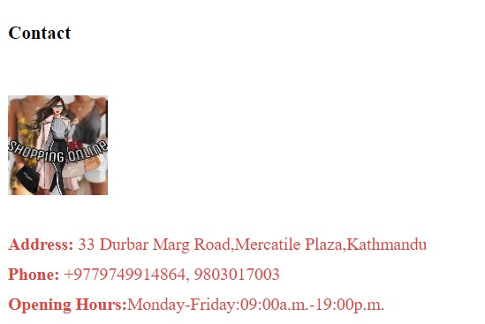

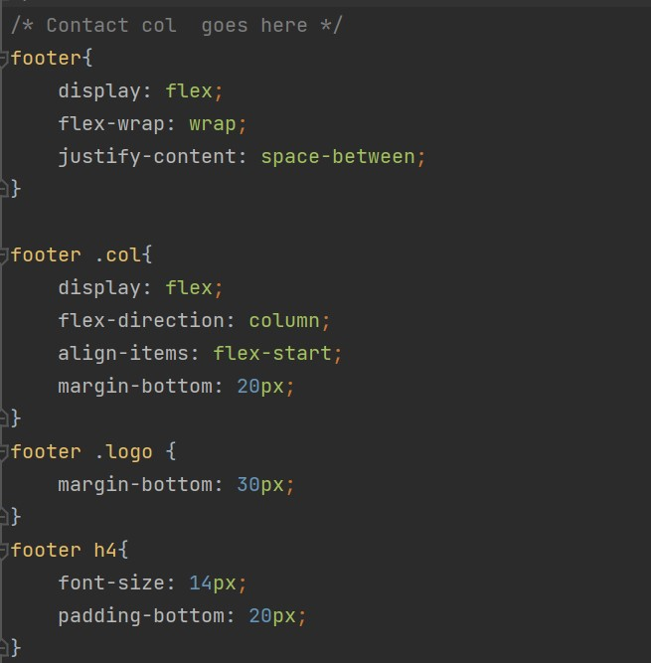

Follows us:

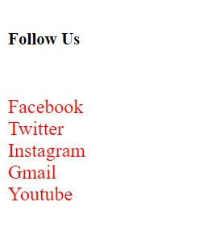

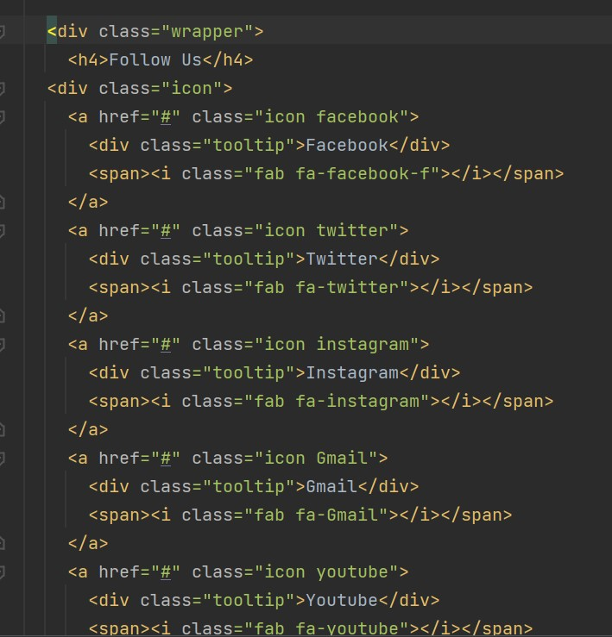

About:

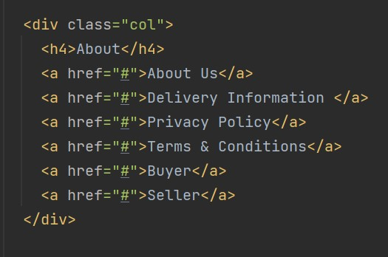

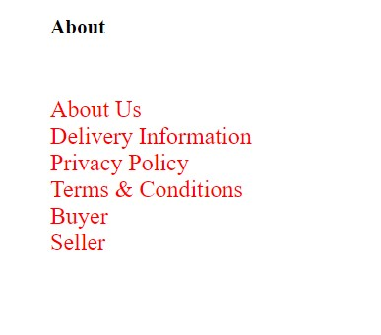

My Account:

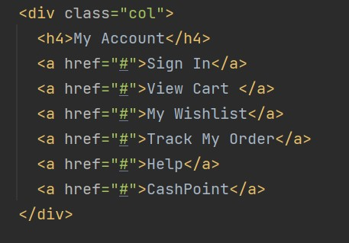

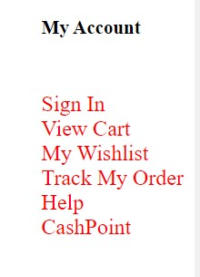

Download App:

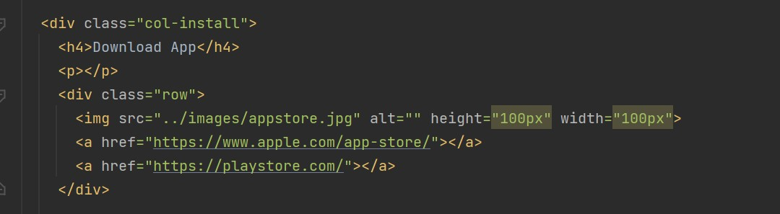

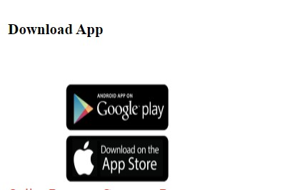

Online Payment Partners:

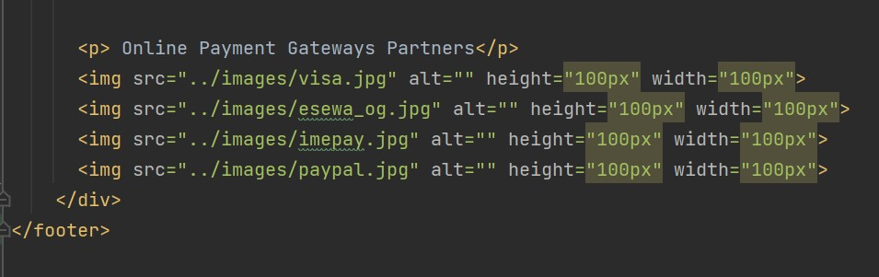



Copyright:

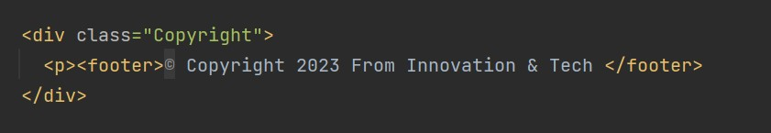

# Issues During the Project Development

During the whole session the codes and its syntax doesn’t match which was error occurring again and again. Management of images were hard to select. Linking them were different and same, with alertness the command was input. Due to lack of coordination the project was running out of time. All the members were not present regularly which was difficult to discuss about the project. I have joined the 3rd almost after 2.5years which was quite hard for me to code and interpretation. Understanding the code was very different for me especially. Beside this I have faced a lot of situations while coding and a hard part for me was to write the CSS but while seeing references I have managed though which was not absolutely fine. As a Front-end developer:

* From where to start and end was very confusing I have managed very hardly.
* Implementation of CSS was very unknown while adjusting and selection of tags and properties and color combination.
* Changing from column to row was hard to understand.
* Closing and non-closing tags were easy to handle.
* Errors occurs randomly while writing and the spellings.
* GitHub is required for project pushing where many users can see our project, sometimes the command was not posted so tried a lot times.

# Project Limitation

A project should be easy and simplicity, a misleading of project shouldn’t be complex. If we don’t understand the project then a lot of difficulties in delivery are seen. To prepare the diagram for planning better, which should be flexible, open for changes and modifications. A quiet fair and reliable data, any procedure can lead to mistake and brings less than perfect data, Time constraints. Conflicts arising from cultural bias regarding personal issues. Lack of capacity, inability, arms limitation, limitation of imports.

In The security system, most probably, people are hesitant to provide the financial details for advanced data encryption in places, whereas there could be fraudulent. A lack of privacy, Tax issues, legal issues, technical limitation, Delivery Guarantee etc. Products returns and exchange, Bargain about the products are prohibited.

# Future Works

To advertise the company in social media platform where from new clients can be gathered towards our company. TO launch the offices, branch offices in different sectors of company. Online Payment Partner for visa/Mastercard/imepay/eSewa/PayPal etc. A company server should be installed rather than online.

Electronic POS system inclusion for card swipe methods. Mobil Banking features should be preferred seriously. A digital marketing for the products as well as company website. A skillful internship member should be haired while other are introduced. Many required change we bring for the traffic over the website solution. Engagement with website and client required facilities should be increased. Expansion of business. Validation and verification behavior will be launched. A local and worldwide business methods. Brand partners with marketing team for addition of more sellers. Change for tools and technologies are acceptable.

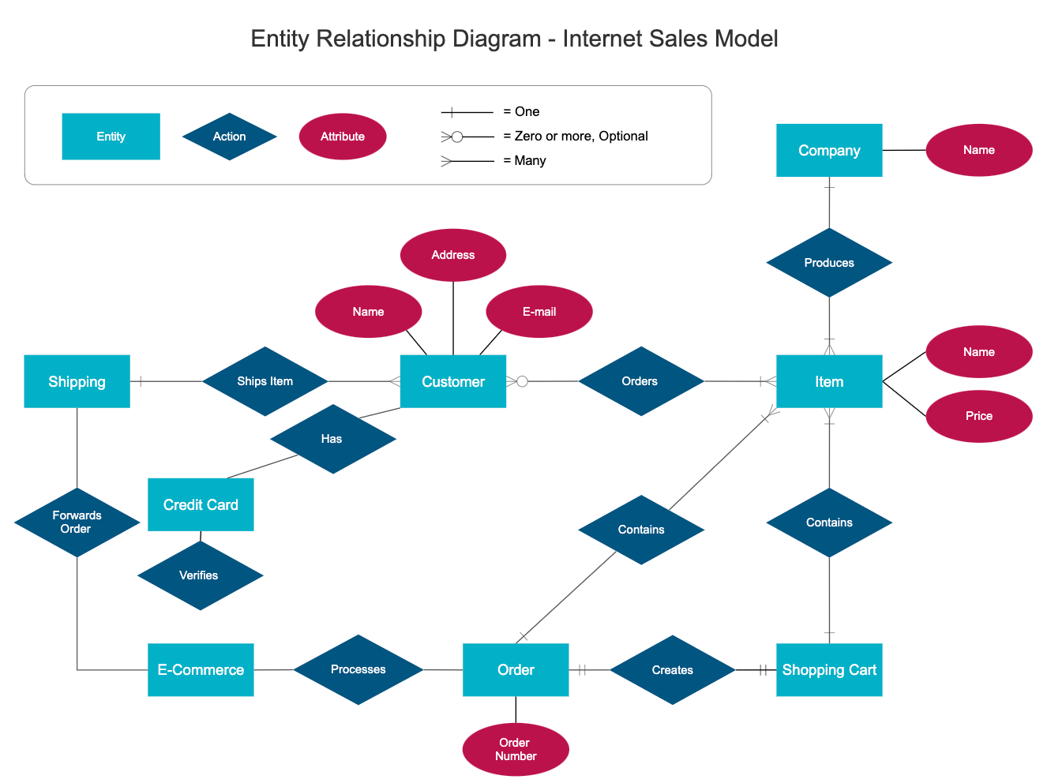

# Conclusion:

Overall, these are the details of our project and what it intends to do. By working on a agile methodology, we as a team members ensure proper collaboration, division and contribution on this project.

# Similar Products: